TEMPLATE FOR FULL PAPER(TITLE)

Noreen Ayob^{1,*}, Chong Fei Sze¹ & Mohd Anuar Arsyad²
¹Kolej PERMATApintar,
Pusat PERMATApintar® Negara, Universiti Kebangsaan Malaysia, 43600 UKM Bangi, Selangor, Malaysia

²Program ASASIpintar,
Pusat PERMATApintar® Negara, Universiti Kebangsaan Malaysia, 43600 UKM Bangi, Selangor, Malaysia

*Corresponding author: noreen@gmail.com

ABSTRACT

Abstract must be prepared in English using Microsoft Word. The abstract must be single-spaced in block format (without paragraph indentation), using 11-pt Times New Roman on A4 layout. It should not exceed 250 words. It should briefly summarize the essence of the paper and address the following areas without using specific subsection titles. Objective: Briefly state the problem or issue addressed, in language accessible to a general scientific audience. Technology or Method: Briefly summarize the technological innovation or method used to address the problem. Results: Provide a brief summary of the results and findings. Conclusions: Give brief concluding remarks on your outcomes. The font sizes should be 12-pt for the title, 11-pt for authors’ names, 11-pt for affiliations and corresponding author’s email address, and 11-pt for keywords.
Keywords: keyword1; keyword2; keyword3 (please give 3-5 keywords)

1.0 Introduction

For your paper to be published in the conference proceedings, you must use this document as both an instruction set and as a template into which you can type your own text. If your paper does not conform to the required format, you will be asked to fix it.
It is expected that authors will submit carefully written and proofread material. Spelling and grammatical errors, as well as language usage problems, will reduce the chances the paper to be published. Paper should be comprised of no more than 10 (ten) pages.
Note that the organization of the body of the paper is at the authors’ discretion; the only required sections are Introduction, Literature Review, Methods or Procedures, Results, Conclusion, and References. Acknowledgements and Appendices are encouraged but optional. Technical terms should be explained. Acronyms should be written out at their first appearance.

2.0 Procedure for Paper Submission

Pusat PERMATApintar® Negara manages the peer review and production processes for publication. All submissions to the proceedings must be completed electronically via email.
These guidelines include complete descriptions of the fonts, spacing, and related information for producing your proceedings manuscripts. Please follow the guidelines properly.

3.0 Paper Style

All paragraphs must be indented. All paragraphs must be justified.

3.1 Text Font for Main Text

Required font for main text is Times New Roman, 12-pt and single-spaced.

3.2 Title and Authors Details

All title and author details must be in single-column format and must be centered. Every word in a title must be capitalized, font 12-pt Times New Roman and bold.
Author details must not show any professional title (e.g. Managing Director), any academic title (e.g. Dr.) or any membership of any professional organization (e.g. Senior Member IEEE). Font for authors’ names is 11-pt and Times New Roman. Font for affiliation and corresponding author’s email address is 11-pt and Times New Roman.

3.3 Figures and Tables

Figures and tables must be centered in the column. The figures should be numbered and captioned. Graphics can be in full color but will be printed in black and white. All figures/tables should be integrated in the text. Please ensure that the manuscript has been “spell-checked” and “grammar-checked”. Graphics must not use stipple fill patterns because they may not be reproduced properly. Please use only SOLID FILL colors which contrast well both on screen and on a black-and-white hardcopy, as shown in Figure 1 and Figure 2.

Please check all figures in your paper both on screen and on a black-and-white hardcopy. When you check your paper on a black-and-white hardcopy, please ensure that:
• The colors used in each figure contrast well,
• The image used in each figure is clear,
• All text labels in each figure are legible.

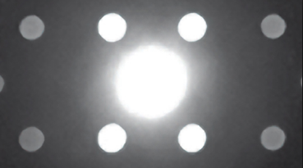
Figure 1. Example of a figure
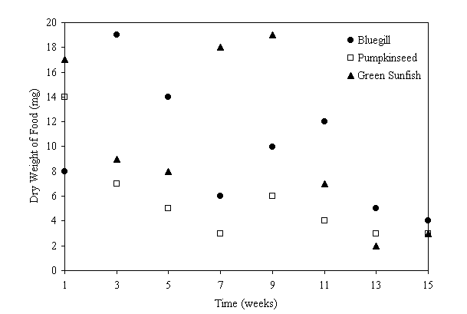
Figure 2. Weekly changes of dry weight of food eaten by sunfish species

Figures must be numbered using Arabic numerals (e.g. 1, 2, 3, 4, etc.). Please make sure that all figures are uniquely and consecutively numbered starting from 1 in increasing order. Figure captions must be in 11-pt Times New Roman and must be positioned under the figures. Please center the captions as shown in Figure 1 and Figure 2. When referring to a figure in text, please use the “Figure 2” rather than “Figure (2)”.
Tables must be numbered using uppercase Arabic numerals (e.g. 1, 2, 3, 4, etc.). Please make sure that all tables are uniquely and consecutively numbered starting from 1 in increasing order. Table captions must be in 11-pt Times New Roman. They must be centered, and captions with table numbers must be placed above their associated tables, as shown in Table 1. When referring to a table, please use the “Table 1” rather than “Table (1)”.

Table 1. Font sizes of headings. Table captions should always be positioned above the tables
Heading level | Example | Font size and style
Title (centered) | PROCEEDING … | 12 point, bold
1st-level heading | 1.0 Introduction | 12 point, bold
2nd-level heading | 2.1 Structure | 11 point, bold
3rd-level heading | Headings. Text follows … | 10 point, bold
4th-level heading | Remark. Text follows … | 10 point, italic

3.4 Page Numbers, Headers and Footers

Page numbers, headers and footers must not be used.

3.5 Equations

Equations should be centered in the column and numbered sequentially. Place the equation number to the right of the equation within a parenthesis, with right justification within its column. An example would be

$∇×H=J+\frac{∂D}{∂t}$ (1)

Make sure that all parts of your equations are legible and are not too small to read. When referring to an equation, please use the number within parenthesis. For example, “Equation (2)” rather than “Equation 2”.

3.6 Citation and References

Remember to cite your sources in the Introduction and throughout the manuscript. Cite papers using author-date style like this Metey and Veiko (1998). If you cite the paper at the end of a sentence, please write (Zhang, Zhu, Sin & Mok, 1999).
Articles and books are cited the same way in the text, yet they appear different on the References page. For example, an article by Hamzah and Hussain (2004) and a book by Bandura (1986) are written with the authors’ names and the year of the publication in parentheses. However, if you look on the References page they look a little different. Another thing about citations are important. When a citation is written inside parentheses (e.g., Hamzah and Hussain, 2004), an ampersand is used between authors’ names instead of the word “and.”
The heading of the References section must not be numbered. All reference items must be in 11-pt Times New Roman and use Author-Date Style format. The list of references must be typed single-spaced and in alphabetical order. Examples of reference items of different categories shown in the References section include:
- example of a book in Bandura .
- example of a chapter in a book in 2.
- example of a journal article in 3.
- example of a thesis in 4.
- example of an electronic reference materials in 5.
- example of a proceeding in Rahmat, Jumari, Hassan and Basri (2002). If you cite the same article for more than once, please write Rahmat et al. (2002).
- example of a book which works that are known by their titles in 7.

4. 0 Conclusion

For ease of formatting, please use the styles listed in Table 1. The styles are defined in this template file and are shown in the order in which they would be used when writing a paper. If your WORD document contains equations, you must not save your WORD document from “.docx” to “.doc” because when doing so, WORD will convert all equations to images of unacceptably low resolution.

Acknowledgement
These should be brief and placed at the end of the text before the references.

References

Bandura, A. 2010. Publication Manual of the American Psychological Association. 6th Ed. New York: Academic Press.
Fleishman, I.A. 2011. Twenty years of consideration and structure. In Fleishman, I.A. & Hunt J.G. (ed.). Current Development in the Study of Leadership: Selected Readings, pp. 1-37. Carbondale: Souther Illinois University Press.
Hamzah, N. & Hussain, A. 2004. A new approach to locate the voltage sag source using real current component. Journal of Electric Power System Research 72(2): 113-123.
Howie, J. 2007. Topics in the theory of groupoids. Ph.D. Thesis, University of London.
Medical Information Group. 2008. Arsenic contamination of drinking water. http://www.cit.edu/phys/sensor.html [4 July 2008].
Rahmat, R.A., Jumari, K., Hassan, A. & Basri, H. 2002. Intelligent traffic control with image processing sensor. Proceedings of the 2nd World Engineering Congress, pp. 339-344.
The Encylopaedia of Islam. 2006. 2nd Ed. Leiden: E.J.Brill.

