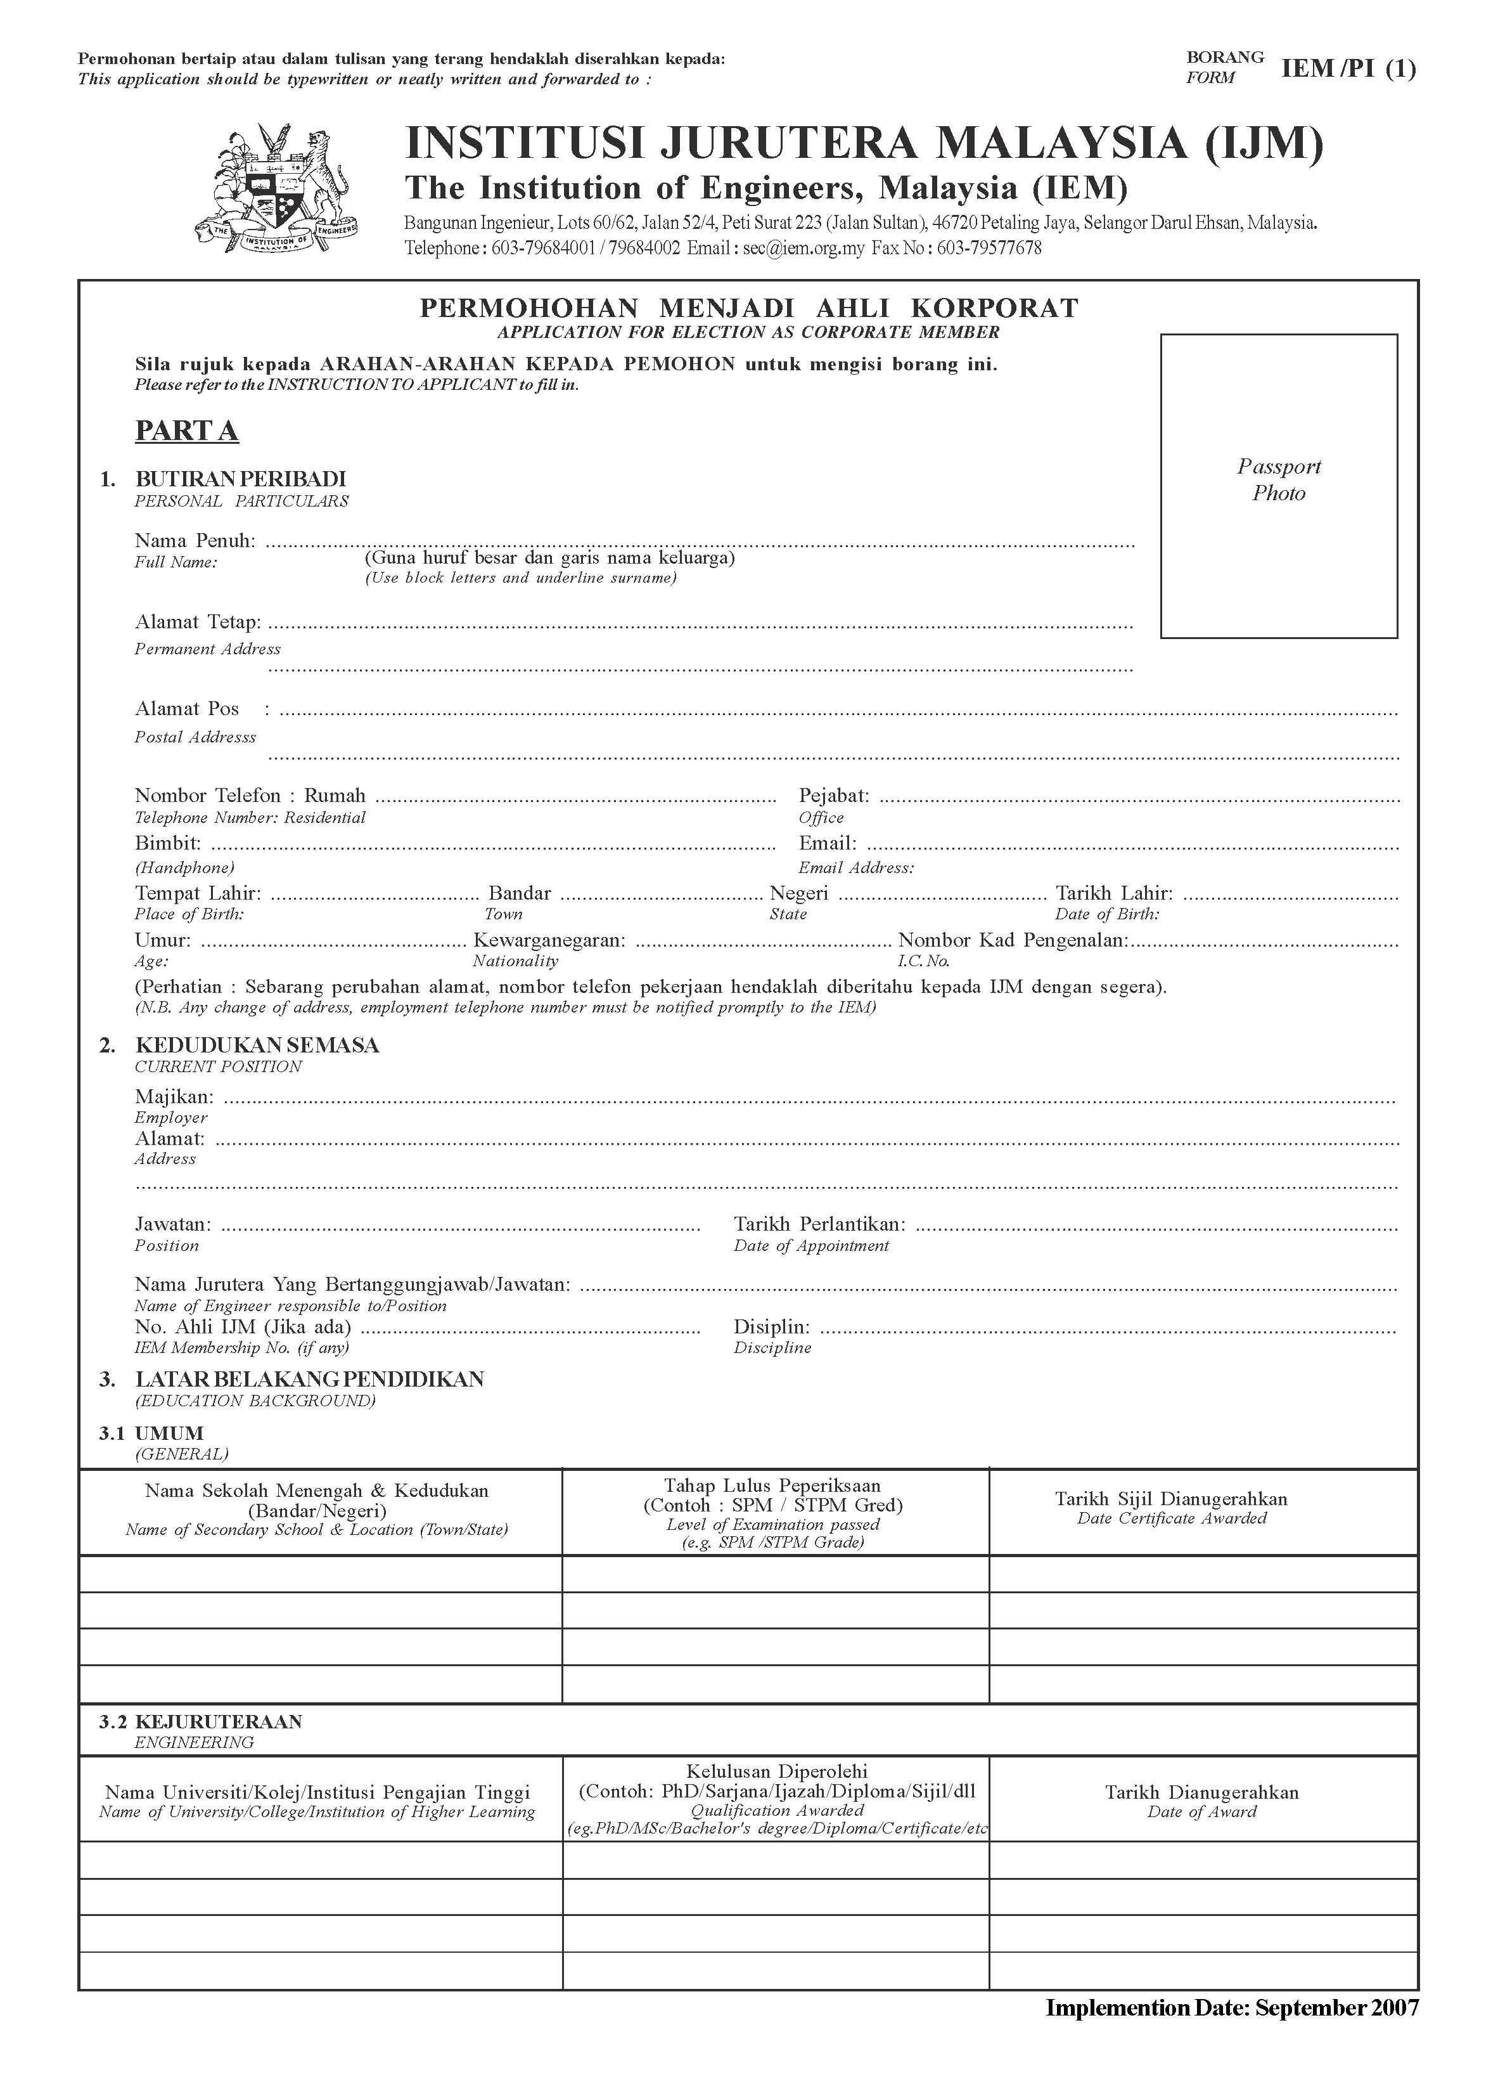

ABU BAKAR BIN SULONG
No 41, Jalan Harmoni 11/3, Taman Harmoni , Seksyen 6 Bandar
Teknologi Kajang, 43500 Semenyih, Selangor
Jabatan Kejuruteraan Mekanik dan Bahan, Fakulti Kejuruteraan dan Alam Bina,
Universiti Kebangsaan Malaysia, 43600 UKM Bangi, Selangor
+60 (3) 87235677
+60 (3) 8921 6678
21 September 20111965
Kampung Buloh
Kuala Berang
Terengganu
abubakar@eng.ukm.my
Removed
Removed
Malaysia
34 tahun

Pendaftar, Universiti Kebangsaan Malaysia, 43600 UKM Bangi, Selangor Darul Ehsan

Universiti Kebangsaan Malaysia

Pensyarah Universiti

Removed
PROF IR DR YUSOFF ALI

Kejuruteraan Mekanikal

F2202

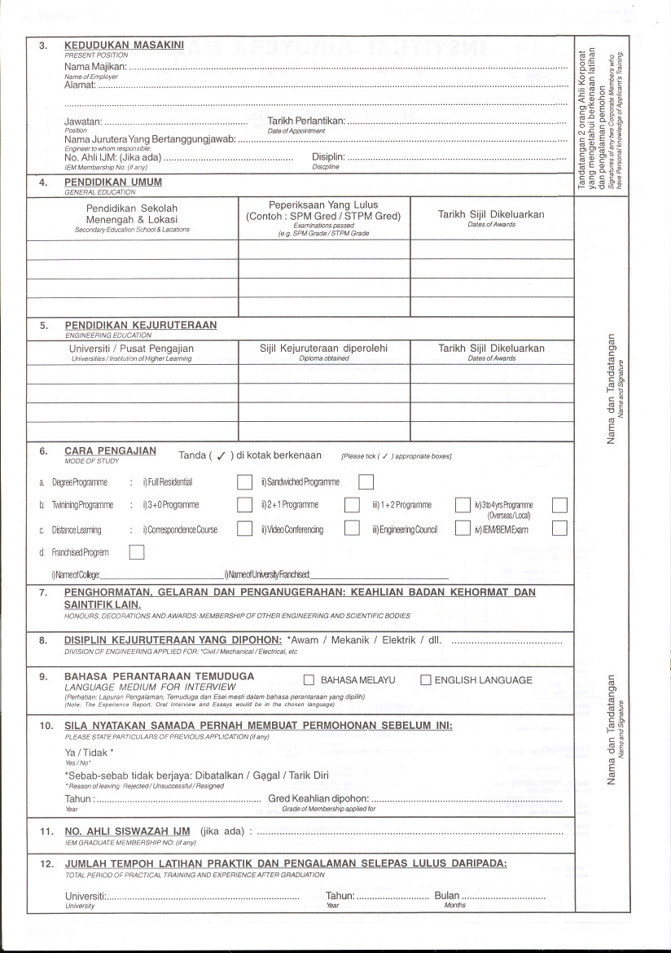

Sek. Men. Sultan Zainal Abidin, Terengganu | Sijil Rendah Pelajaran – Gred 1 | 1992
MRSM Kuala Terengganu, Terengganu | Sijil Pelajaran Malaysia – Gred 1 | 1994

Gifu University, Japan | Bachelor of Engineering (Mechanical & Systems Engineering) | 24 March 2001
Sejong University, South Korea | Doctor of Engineering (Mechanical Engineering) | 15 February 2008
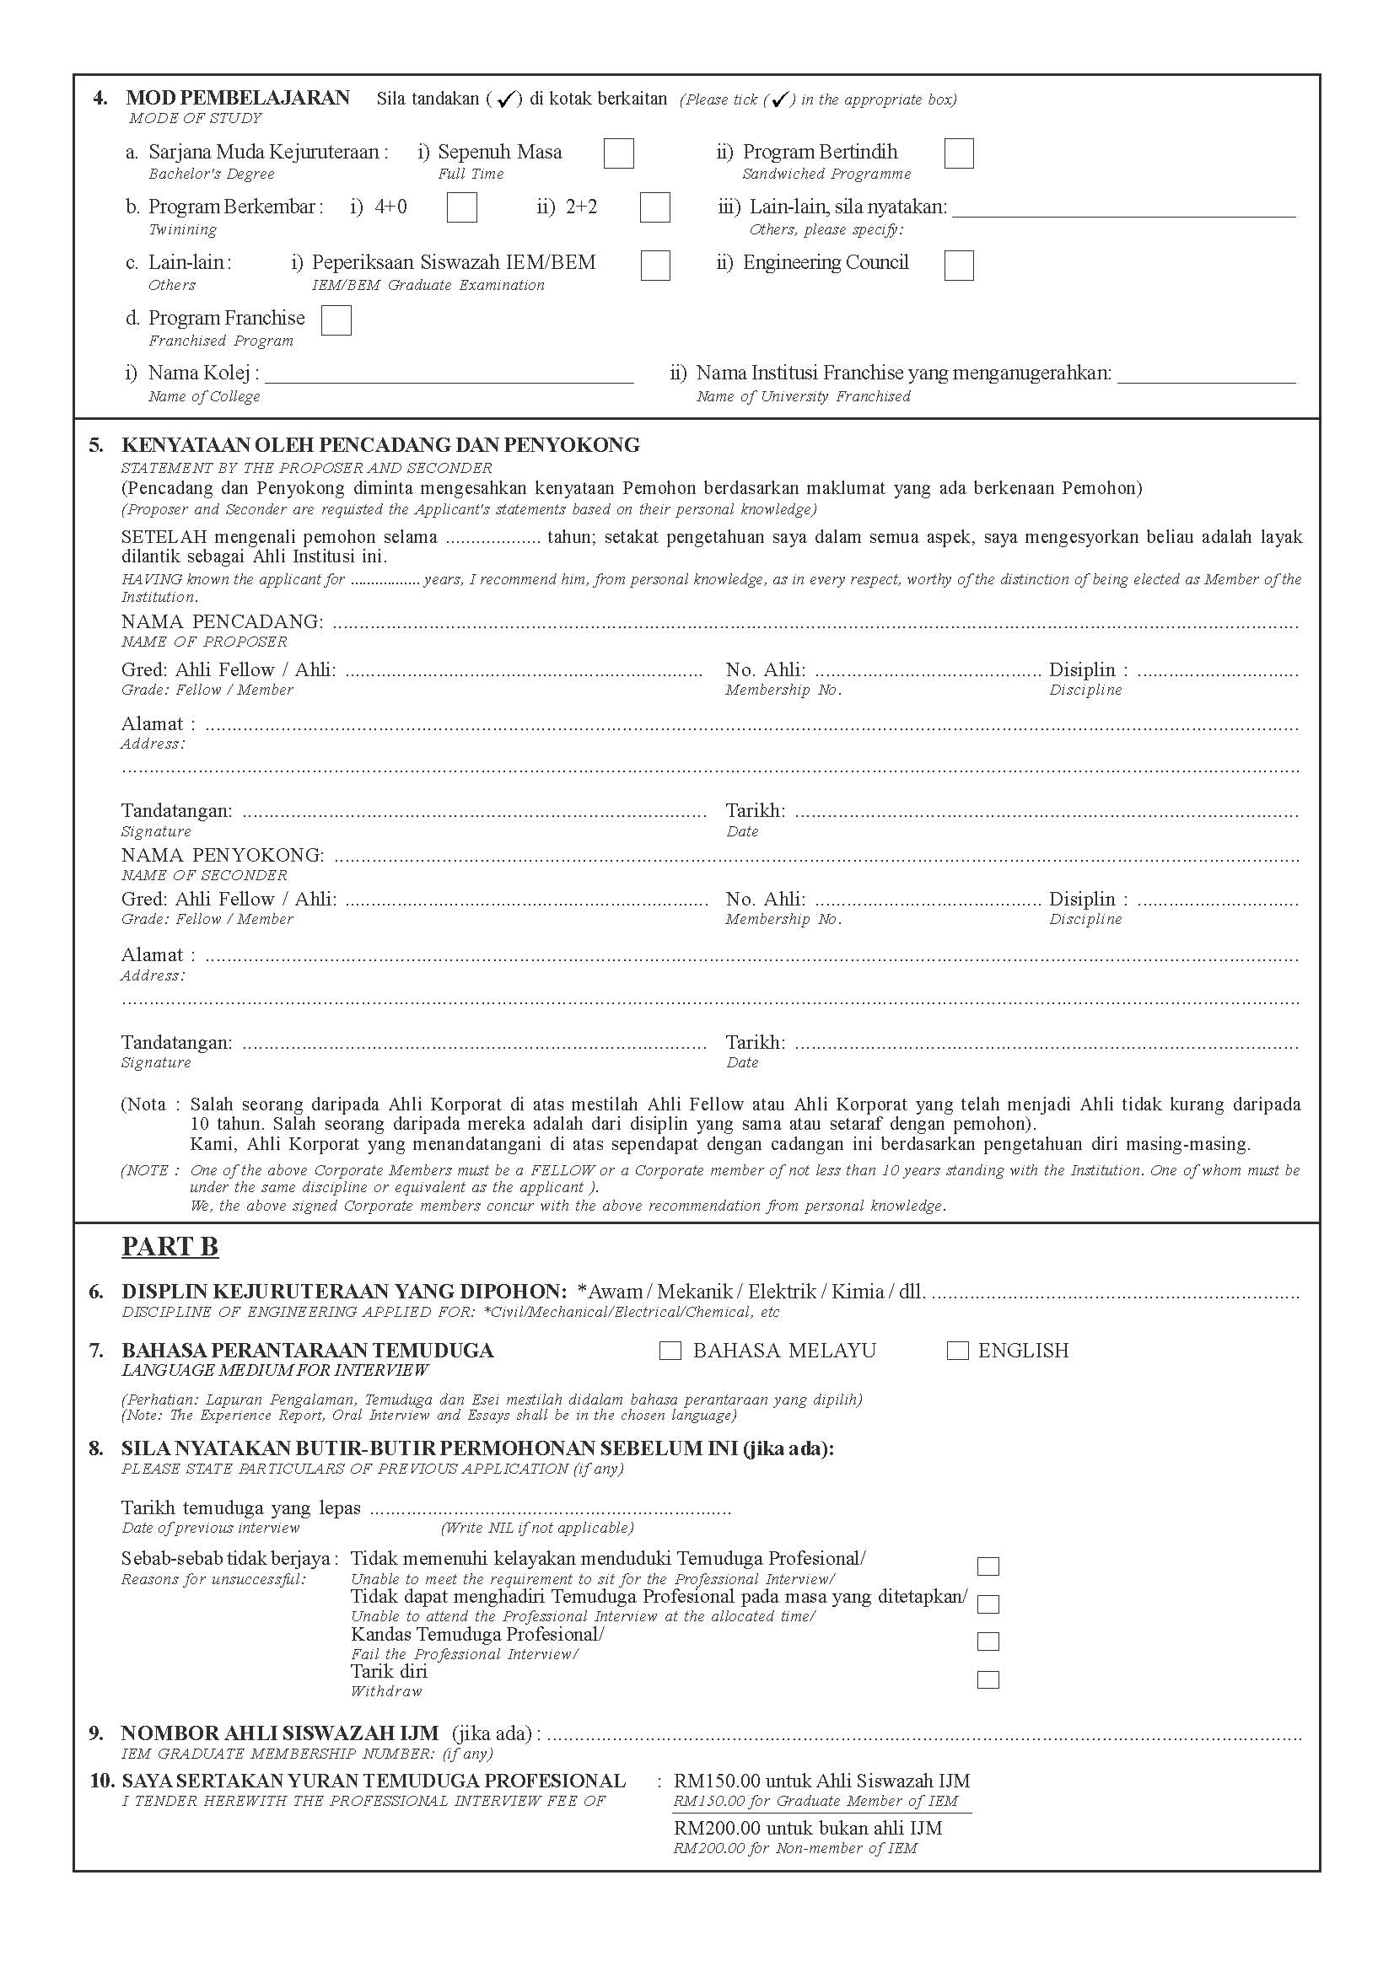

Gifu University, Japan

4

F2202
Fellow

PROF IR DR YUSOFF ALI
Mechanical
PE 4703

39 Jalan SS3/49, Kelana Jaya, 47300 Petaling Jaya, Selangor, Malaysia

Mechanical
PE 12880

IR. ZAMBRI HARUN

M23073

Ahli

No 153, Jalan Sari Ilham 1/5, Alam Sari, 43000 Kajang, Selangor

Mechanical

Registered with BEM (43090A)

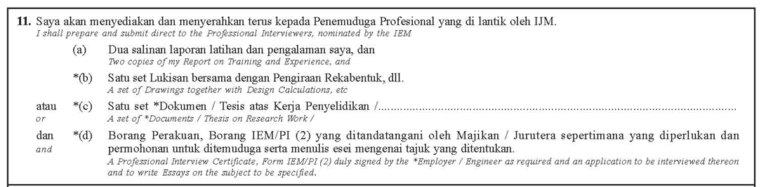
Research Reports
PROFESSIONAL EXPERIENCE
A | B  STATEMENT OF TRAINING & EXPERIENCE  (SINCE REGISTRATION AS GRADUATE ENGINEER) | C | Experience area  (in months) |  |  |  |  |  | E
Date  (months & year) related to each appointment from  Example July 90 to May 95 | State concisely Title of Position held, Name of Employer, Location and Description of each work (make statement brief and concise, designating each work upon which engaged with or change of position separately: include some indication of magnitude and complexity of work in which engaged, your duties and degree of responsibility) If necessary additional sheets may be attached. | Name, Position and Address of Professional Engineer under whom served. | Total | D1 | D2 | D3 | D4 | D5 | Signatures of any Professional Engineers who has personal knowledge of Applicant’s training or experience in the period mentioned.
 |  |  |  | Design/Office | Site / field | Planning/Management | Other Engineering works | Masters /post graduate study/ research/teaching
April 01 – Nov 2001 | Training Engineer (R&D Department)  SMK Corporation, Japan  Ibaraki Branch  Work scope :  R&D training of products manufacturing in SMK Electronics (M) Sdn Bhd. It covers from requirement from customer and discussion, research & design, testing for quality approval, and monitoring of pilot manufacturing. | Mr Sakuragi (Senior Engineer, Ibaraki branch of SMK Corporation) | 8 | 6 | 1 | 1
Dec 01 - Dec 2002 | R&D Engineer  SMK Eelectronis (M) Sdn Bhd, Beranang, Selangor  Work scope :  R&D of products manufacturing for SMK Electronics (M) Sdn Bhd. It covers from requirement from customer and discussion, research & design, monitor parts development at vendors, testing for quality approval, monitoring of manufacturing jig development, monitoring of pilot manufacturing and response to any problems relate to design defect at quality assurance stage. | Mr Wong (Senior Engineer, SMK Electronics M Sdn Bhd) | 13 | 7 | 4 | 2
Jan 03 - Nov 2003 | Logistic Engineer  Promaxus Sdn Bhd, Shah Alam, Selangor  Work scope :  Planning mass production of intake and exhaust engine valve for Perodua OEM market. Based on production quantity, purchasing of all related materials, tools, jig and planning for production capacity. Then, control delivery to customer. | En Mohd Hidzir Yahaya  (Managing Director, Promaxus Sdn Bhd) | 11 | 1 |  | 8 | 2
Dec 03 - Mac 2004 | Tutor  Dept. Mechanic and Material Engineering  Universiti Kebangsaan Malaysia , Selangor  Work scope :  Helping student on tutorial and work lab in Dept of Mechanical and Materials Engineering, UKM | Prof Dr Ahmad Kamal Ariffin  (Head Department Mechanical & Materials Engineering, UKM) | 4 |  |  |  |  | 4
April 04 - Feb 2008 | PhD Student Researcher  Dept of Mechanical Engineering (Advanced Material Processing)  Work scope :  Doing PhD full time in the field on polymer nano composite  - Preparation and characterization of carbon nanotubes for reinforcement fillers  - Carbon nanotubes reinforced epoxy composites  - Alignment of carbon nanotubes in polyethylene through extrusion  - Alignment of carbon nanotubes in polyethylene fibers through melt spinning | Prof Dr Joohyuk Park  (Head Dept. of Mechanical Engineering, Sejong University, South Korea) | 46 | 6 | 2 |  | 2 | 36
March 08 - Oct 11 | Lecturer at the Dept of Mechanical and Materials Engineering, UKM  Work scope :  Teaching undergraduate and postgraduate, student mentor, supervise undergraduate and postgraduate in research, collaborate with industries and other institution in research, organize and participate in short course, seminar, workshop, conference in Malaysia and overseas  Final two years engineering course and postgraduate course  - Manufacturing process KP3023 (4 semesters)  - FEM for Manufacturing KP4263  (4 semesters)  - Facilities Planning KP3433  (1 semesters)  - Mechanics of Polymer & Composite KJ4553  (2 semesters)  - Polymer & composite processing KP6123  (5 semesters)  - CAD/CAM KP6523  (5 semesters) | Prof Dr Norhamidi Muhamad (Head Dept of Mechanic and Materials, UKM) | 18 | 2 | 3 | 2 |  | 11 | Signature
March 08 - Oct 11 | Research and Development  - Development and Design of Jig for Computer assisted Total Knee Replacement (25/8/2008 ~ 30/11/2011)  Principal Researcher  - Influence of improvement bipolar plate conductivity on the performance of stack for PEMFC  (1/6/2008 ~ 30/6/2012)  Co-researcher  - Bahan Baru dalam Sel Fuel dan Tenaga Hidrogen  (1/7/2009 ~ 30/6/2012)  Co-researcher  - Application of micro injection molding for fabrication of dental surgery components (1/7/2009 ~ 31/12/2011)  Co-researcher  - Development of A Novel Method to Produce Polymer Fiber Using Electrospinning  (26/11/2009 ~ 30/4/2012)  Principal reseacher  - Design and Fabrication of Surface Topology as a tool for Stem Cells Differentiation through Morphological Regulation  (1/10/2010 ~ 30/9/2012)  Co-researcher  - Design, fabrication and performace test 5kW Cell Fuel Car  (1/10/2010 ~ 30/9/2012)  Co-researcher  - A Novel process of Incorporating Chemical Surface Modified Stainless Steel/Carbon nanotubes in polymer Matrix Composites  (1/6/2010 ~ 30/6/2012)  Principal researcher  - Effect of Metal Injection Molding (MIM) Processing Parameters on the Intra Networking Phase of Novel Hybrid Materials (6/6/2011 ~ 5/6/2013) Principal researcher  - Effect of vanadium Carbide (VC) on the Properties and Microstructure of Ultrafine tungsten Carbide (WC-10C0) Component Produced by Micro Powder Injection Molding Process (6/6/2011 ~ 5/6/2014)  Co-researcher  - Characterization and Peridynamic Modeling of Shape Memory Alloy-based Self-Healing Composite Aerospace (21/6/2011 ~ 20/12/2013) Co-reseacher  - Electrically Conducting polymer Composites for fuel Cell Bipolar Plate(21/6/2011 ~ 20/6/2014)  Co-reseacher  - Characterisation and Evaluation of  the Effect of Nano Powders in the Metal Injection Molding Process  (21/6/2011 ~ 20/6/2014) Co-researcher | Prof Dr Che Hassan Che Haron (Director, Centre of Research & Innovation Management, UKM) | 27 | 4 | 2 | 4 | 1 | 16
 |  | Total  Months | 127 | 26 | 12 | 17 | 5 | 67

