Title of Full Paper (Maximum Two Lines)
Firstnameone Lastnameone^{1*}, Firstnametwo Lastnametwo², and Firstnamethree Lastnamethree³
¹ Affiliation, City, Country
Email: one@xxx.com
² Affiliation, City, Country
Email: two@xxx.com
³ Affiliation, City, Country
Email: three@xxx.com
*Corresponding Author
Abstract. This MS Word document is written in the format required a paper submission for the 19th East Asia-Pacific Conference on Structural Engineering & Construction (EASEC-19), “Advancing Sustainability in Structural Engineering and Construction Through Emerging Technologies”. The font type of the abstract is Times New Roman. The abstract should be between 150 - 300 words. A4 paper should be used. Page margins should be 2.5 cm for the left margin, 2.5 cm for the right margin, and 2.5 cm for the top and bottom margins. The paper title (14 points, Bold and Centered) can have a maximum of two lines. Author’s names are written in full (e.g., Yang Wei). The list of authors is followed by the respective affiliation, country, and email with an underline. The corresponding author should be indicated with the asterisk (*). The abstract text should be 11 points regular with single line spacing, justified and paragraphs are not indented.
Keywords: One line of text separated by a semicolon, in the format of Times New Roman 11-point. No more than 5 keywords
1. Introduction
The full paper in a Microsoft Word file should be written in compliance with these instructions and submitted in Word format via the online submission system on the conference website at https://www.ukm.my/easec19/. Authors are required to carefully proofread material before submitting it. Papers must be prepared in correct English. SI units should be used. Paper length should be 4-6 pages, including references and appendices. Papers should describe the background of the subject, the authors’ work, including the methodologies used, discussion on the importance of the work, and concluding remarks. Technical terms should be explained unless they are known to the broader scientific community. Terms, acronyms, and abbreviations should be mentioned at their first appearance.

2. Paper format
Authors are recommended to use this template to prepare their papers. This template is an A4 format with 2.5 cm for the left margin, 2.5 cm for the right margin, and 2.5 cm for the top and bottom margins. All text paragraphs should be typed in a single space. Double spacing should only be used before and after headings as shown in this example. No spaces should be placed between paragraphs.

2.1 Page Numbering, Header, Footer
Do not insert page numbers. Do not write in headers and footers or change them.

2.2 Fonts
The paper text should be in Times New Roman font, with 12 points and single line spacing. Only the following text should be italicized: mathematical parameters (not for log, sin, cos, ln, max., d (in dx), etc). Never use bold for paper text, except to denote vectors in mathematics. Do not underline text. Use the 10-point font, bold for tables and figure captions, and use the 10-point font, normal for the references.

2.3 Figures and Tables
All figures and tables should be numbered in order of appearance in the text. Figure captions should be centered below the figures and table captions should be centered above the tables. Insert figures and tables as close as possible to the location where they are first mentioned in the text. Figure and table captions should clearly explain the figure/table without needing to refer to the text and should be typed in 10-point bold Times New Roman font, with only the first letter of the first word capitalized. Figures and tables that have not been mentioned in the text should not be presented.

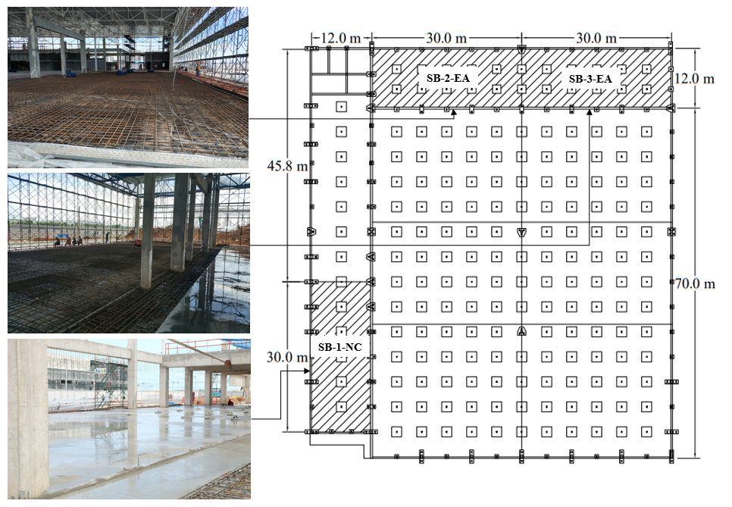
Figure 1. Caption in 10 pt times new roman, capitalize only the first letter of the first word

Table 1. Caption in 10 pt times new roman, capitalize only the first letter of the first word.
Parameters | Values

2.4 Equations
Each equation should be presented on a separate line from the text with a blank space above and below. Equations should be clear, and the expressions used should be explained in the text. The equations should be numbered consecutively at the outer right margin, as shown here below:

a + b = c (1)

2.5 References
References in the body of the text must be cited as authors’ surname following by the year of its publication, e.g., Tang and Zhu 2022 or Fang et al. 2021. At the end of the paper, list all references in alphabetical order of the first author’s last name, in a separate “References” section. The references should be in Roman script and typed using the References style (10-point font, second and further lines indented by 9.5 mm). If several works by the same author are cited, entries should be chronological. If there is more than one paper by the same authors in a year, the references should be distinguished by attaching a small alphabet in chronological order (e.g., Yang and Xie (2020a), Yang and Xie (2020b)). See also examples in the "References" section at the bottom of this template.

3. Conclusions
‘Conclusions’ section is required. A conclusion should address all the concluding remarks including the introduction, methods, innovation, and significance of the research/study, and basically, review the main points of the paper. Do not replicate the abstract as the conclusion.

Acknowledgements
This optional heading should be inserted just before the References heading, both headings (Acknowledgements and References) being without numbering.

References

Cascione, V., Maskell, D., Shea, A. et al. (2019), A review of moisture buffering capacity: From laboratory testing to full-scale measurement, Construction and Building Materials, 200, pp. 333-343

Sasika, B., Thomas, J., Ramaswamy, K. et al. (2005), Performance of hybrid rebars as longitudinal reinforcement in normal strength concrete, Materials and Structures, 38(284), pp. 857-864

Van, V.K., Kiekens, P., and Van, L.L., Basalt fibres as reinforcement for composites, In: Proceedings of the 10th International Conference on Composites/Nano Engineering, New Orleans, LA, USA, 2003, pp. 20-26

