Automation of Solar Flare Observation Using Graphical Interface

(Automasi Pencerapan Nyalaan Suria menggunakan Antara Muka Grafik)

Mohamad Zulfahmi Bin Mohamad Izham^{a*}, Mardina Binti Abdullah^{a,b}, Siti Aminah Binti Bahari^{b}, Gan Kok Bengª & Sabirin Bin Abdullah^{b}

ªDepartment of Electrical, Electronic and Systems Engineering, Faculty of Engineering & Built Environment, Universiti Kebangsaan Malaysia, Malaysia
^{b}Space Science Centre, Institute of Climate Change, Universiti Kebangsaan Malaysia, Malaysia
*Corresponding author: zulfahmi7izham@gmail.com

ABSTRACT

Solar activity such as solar flares causes increased X-ray and ultraviolet ray flux. This event will cause sudden ionospheric disturbances (SID) and disrupts the communication systems as well as the space-based equipment on Earth. Public awareness on the effects of solar activities towards humans on Earth is very important as the dependency of human daily life on space technology is increasing. Exposure to the community, especially school students has been conducted by the Space Science Center, Institute of Climate Change, UKM since 2011 using UKM-SID™ system. Based on the conducted program, it was found that school students and teachers experienced constraints in the process of analyzing data due to the absence of computers in schools. Therefore, UKM-SID™ system, with portable kit equipped with an interactive software to produce an easy-to-understand figure, was proposed. Python was used to develop the interactive software. An algorithm was also developed to transfer the observed data onto the server in near real time. The developed Graphical Interface software showed a visualized sunrise and sunset patterns which is in agreement with the previous study. A solar flare was detected on 1 December 2020. The observed data is also successfully uploaded onto the server in near real time. Result shows that this new UKM-SID™ system is able to capture the solar flare occurrence in near real time. This new system is also at an optimal and sophisticated level compared to the technology that has been used. Hence, the researchers believe the UKM-SID™ is able to help educators, students and the general public in the learning of space science more effectively.

Keywords: Solar flare; UKM-SID™; GUI; Python; Very Low Frequency (VLF)

ABSTRAK

Aktiviti matahari seperti suar matahari menyebabkan peningkatan sinar-X dan fluk sinar ultra ungu lampau. Ini menyebabkan berlakunya gangguan ionosfera mendadak dan seterusnya menganggu sistem komunikasi dan juga peralatan berasaskan angkasa di Bumi. Kesedaran masyarakat berkenaan kesan aktiviti matahari kepada manusia di bumi amat penting memandangkan kebergantungan kehidupan seharian manusia terhadap teknologi angkasa semakin tinggi. Pendedahan kepada masyarakat terutama pelajar sekolah telah mula dijalankan oleh Pusat Sains Angkasa, Institut Perubahan Iklim, UKM sejak tahun 201. Berdasarkan program yang dijalankan, didapati pelajar sekolah dan guru mengalami kekangan dalam proses menganalisis data disebabkan ketiadaan komputer di sekolah. Oleh itu, objektif utama kajian ini adalah untuk menaik taraf sistem UKM-SID™ menjadi satu kit mudah alih yang dilengkapi dengan perisian interaktif bagi penghasilan rajah yang mudah difahami. Python digunakan untuk membangunkan perisian interaktif tersebut. Satu algoritma juga dibangunkan bagi membolehkan data yang dicerap dimuatnaik secara hampir masa sebenar ke pelayan. Perisian antara muka grafik pengguna yang dibangunkan menunjukkan corak matahari terbit dan terbenam yang selari dengan kajian terdahulu. Nyalaan suria dapat dikesan pada 1 Disember 2020. Data yang dicerap juga berjaya dimuatnaik ke pelayan hampir masa sebenar. Hasil kajian menunjukkan perisian ini berupaya untuk mengesan kejadian nyalaan suria hampir masa sebenar. Lantaran itu, UKM-SID™ diyakini dapat membantu golongan pendidik, pelajar dan orang awam dalam pembelajaran sains angkasa dengan lebih efektif.

Kata Kunci: Suar Matahari; UKM-SID™; GUI; Python; Frekuensi sangat rendah (VLF)

INTRODUCTION

Solar flare is a large explosion that occurs in the sunspot region when the magnetic energy that has been built up is suddenly released. This event involves the release of charged particles such as protons and electrons into the solar atmosphere (Seaton & Darnel 2017). The rays produced by solar flare are in the form of X-ray or Extreme Ultraviolet (EUV) ray. Both can propagate at the speed of light and take approximately eight minutes to reach and affect the Earth’s ionospheric layer dramatically (Papaioannou et al. 2016).
The Earth’s ionosphere layer contains free electrons that affect the propagation of radio waves. During the occurrence of solar flares, large amounts of EUV and X-rays penetrate the D-layer and increase the rate of ionization. The changes in the ionosphere is known as sudden ionospheric disturbances (SID) (Nina et al. 2017). SID can be detected by monitoring interference at the amplitude of a very low frequency (VLF) signal using a VLF receiver (Šulić et al. 2016). A VLF receiver is a radio frequency in the range of 3–30 kHz (Saccuan et al. 2018).
One of the equipment that has been used to detect the occurrence of SID is Atmospheric Weather Electromagnetic System for Observation, Modeling and Education (AWESOME). While AWESOME is a more sensitive monitor, a researcher from Stanford University has developed a smaller version of AWESOME known as SuperSID, which can be used for learning and research purposes (Abdullah et al. 2013). The differences between AWESOME and SuperSID system are shown in Table 1.

TABLE 1. The difference between AWESOME and SuperSID

No. | system | Hardware | Operation | User
1. | AWESOME | Complex and expensive | More sensitive and accurate timing via GPS | Researcher in space, telecommunications and energy sectors
2. | SuperSID | Concise and cheaper | Smaller sampling rate depending on the sound card used and less sensitive | Educators, students and the general public

Since the occurrence of SID can disrupt radio communication and navigations, it is important to create awareness to the public on the effects of solar activities towards humans on the Earth (Nagem et al. 2018). In line with the Malaysian government vision to create space weather awareness among the public, UKM’s researcher has started to develop their own portable SID detection known as UKM-SID™ since 2011 (Abdullah et al. 2014). This system was developed based on the Super SID schematic owned by the Stanford University (Abdullah et al. 2018).
The first system that has been developed in 2011 consists of loop antenna, preamplifier and a computer (Wong et al. 2012). Table 2 shows the past literature which focused on the development of SID system from year 2015 to 2019. The existing system requires a desktop PC to run the SuperSID software. This is the limiting factor for educators to attract young students towards Science, Technology, Engineering and Mathematics (STEM) education in Malaysia due to energy consumption, cost and also the size of the computer (Soon et al. 2015).
The system then has been upgraded into a portable and low cost system where the Raspberry Pi has been used to replace the computer as a main processor for this SID system. This new system consists of loop antenna, pre-amplifier, an analogue-to-digital converter with Raspberry Pi. The acquisition software in Raspberry Pi is compiled using Python and run on a Linux environment (Deveza et al. 2019).

TABLE 2. Development of SID system (2015-2019)

Researcher | Sound card | Processor | Display | Automation
(Le Minh Tan 2015) | Sound Blaster’s Audigy SE  (Sampling rate: 96 ks/s) | Desktop Window OS | Computer screen | None
(Soon et al. 2015) | Sound Blaster X-Fi Go Pro!  (Sampling rate: 44.1 kHz) | Raspberry Pi Model B (Raspbian Wheezy) | LCD Monitor | None
(Zakaria et al. 2018) | Sound Blaster X-Fi Go Pro!  (Sampling rate: 44.1 kHz) | Data Logger | Computer screen | Semi-automated system
(Deveza et al. 2019) | ADC USB sound card  (Sampling rate: 96 kHz) | Raspberry Pi 3B | LCD Monitor | Semi-automated system

RESULT AND DISCUSSION

Daily automated plot visualization system

The interactive software to produce power versus time plot using GUI has been developed in UKM-SID™ system, where the user can produce power versus time plot directly on the Raspberry Pi. A user can use this software by selecting either 24-hour or 48-hour data depending on the analysis that needs to be done as shown in Figure 6. The observed data from year 2020 has been used to validate this software.

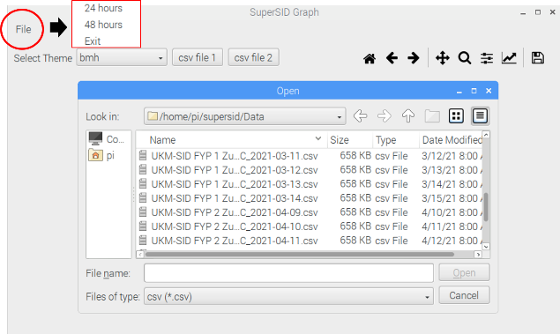

FIGURE 6: Selection of process

Data on 29 October 2020 was used and plotted as shown in Figure 7. The system was located at Universiti Kebangsaan Malaysia, Bangi, Selangor with geographical coordinate of 2.93°N, 101.7°S by using NWC transmitter. A diurnal variation of the 24-hour data was observed where the x-axis represents time in UT and y-axis is the receiving signal strength in watt. It can be clearly seen that sunset appeared at 11:06 am UT.

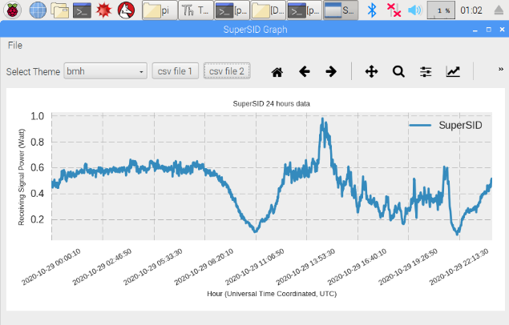

FIGURE 7. 24-hour plot (in UTC time)

One-day plot in local time

As mentioned earlier, a one-day plot in LT is compulsory in this analysis in order to validate and verify the observed data. Data on 26-27 October 2020 was plotted and shown in Figure 8. The system was located at Universiti Kebangsaan Malaysia, Bangi, Selangor with geographical coordinate of 2.93°N, 101.7°S using NWC transmitter. The first process is to verify the sunrise and sunset patterns of the observed data. The sharp downward slope is the process of sunrise while the sharp upward slope is the process of sunset as shown by the red circles in Figure 8.
The sunrise and sunset can be seen at 06:20 am LT and 7:30 pm LT, respectively. The area of determination of the occurrence of solar flares will be referred during the day time (Zakaria et al. 2018). This result is in agreement with the previous study done by Wong et al. (2012), Abdullah et al. (2013) and Soon et al. (2015). The color differences seen in Figure 8 is used to differentiate the data on the first day (blue) and the second day (red). This shows that the developed software is able to observe the daily data at a local station.

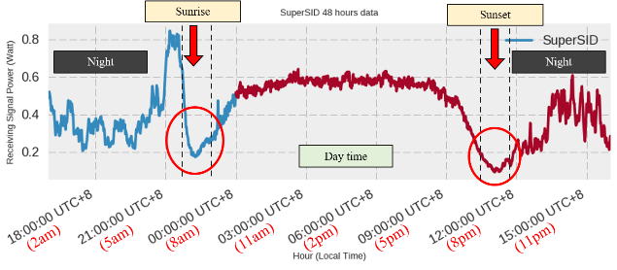

FIGURE 8. 48-hour plot (in local time)

Solar flare detection

To observe solar flares using UT data (24-hour data), the selection area to detect the occurrence of flares is on the left side of the graph starting from 00:00 am until 10:00 am. In other words, the left side represents day time while the right side represents night time.
The process of analyzing a one-day plot (48-hour data) obtained by UKM-SID™ system needs to be done by comparing the data from GOES satellite as shown in Figure 9. This process is important to validate that the system can detect solar flares (Zakaria et al. 2018). Day time is used as flares observation area because the VLF signal can detect the sun activity perfectly as the ionosphere layer is ionized by the sunlight (Toriumi et al. 2016).

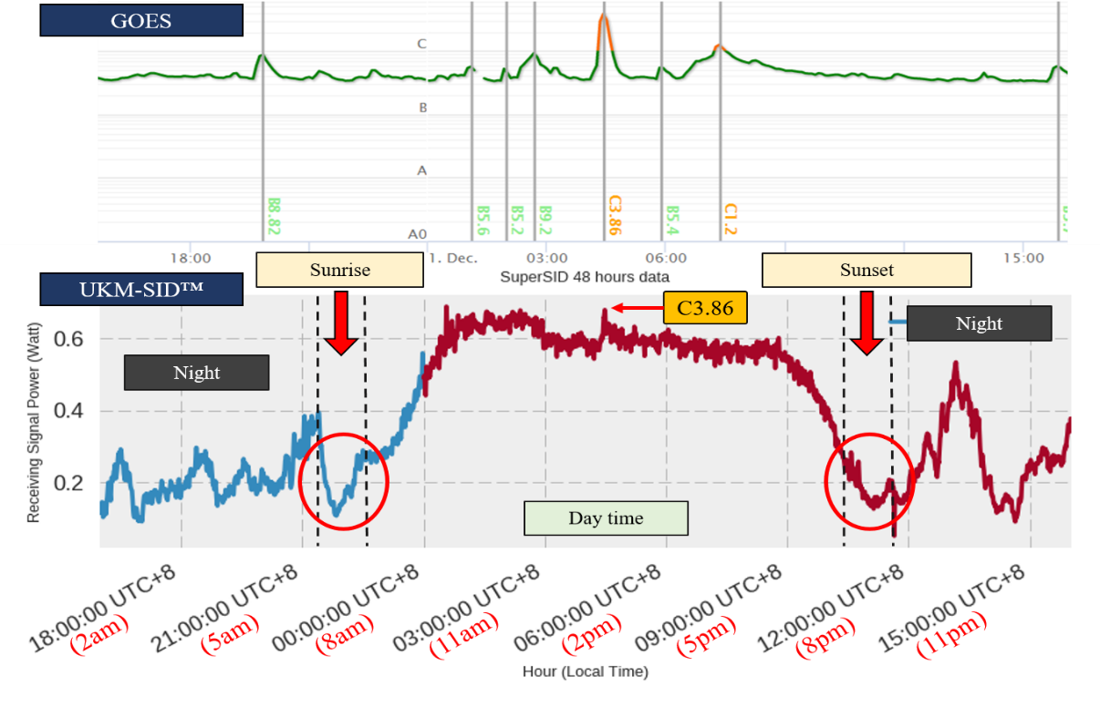

FIGURE 9. Comparing data from UKM-SID™ and GOES

UKM-SID™ has recorded C class flare on 01 December 2020 as shown in Figure 9. From the graph, the flare started at 12:18 pm and reached its maximum peak at 12:35 pm. It then ended at 12:39 pm. By comparing UKM-SID™ with GOES data, the latter recorded the C3.86 flare at 12:08 pm. The maximum peak occurred at 12:27 pm and ended at 12:34 pm. The obtained result shows that there is a delay in the UKM-SID™ system in detecting the occurrence of solar flare where the peak at UKM-SID™ is at 12:35 pm while GOES is at 12:27 pm. The main reason for the delay is because the flares took approximately eight minutes to reach and affect the Earth’s ionospheric layer dramatically.
The UKM-SID™ device is used on the Earth’s surface while GOES data is taken directly from the satellite in space. The other reason is the delay might probably come from the noise and other types of disturbance that affected the radio communication waves between the VLF transmitter and the SID receiver (Guo et al. 2021). GOES satellite data can be obtained online through Space Weather Live website (Space Weather Live 2021). The comparison result shows that the software can be used to detect solar flare occurrences.

CONCLUSION

The development of portable solar flare observation kit or known as UKM-SID™ has developed an automation system for generation of SID power against time graph and data transmission to the server in near real time. This feature provides benefits to the users in terms of time consumption and the latest technology applications that are loaded onto UKM-SID™ portable kit. Finally, this latest version of SuperSID is a helpful teaching aid that can provide an exciting new experience for the users in STEM development and space science education.

ACKNOWLEDGEMENT

The author would like to acknowledge Institute of Climate Change, Universiti Kebangsaan Malaysia for sponsoring this project cost and equipment under the grant of ZF-2019-013.

REFERENCES

Abdullah, M., Majid, R. A., Bais, B., Bahri, N. S. & Asillam, M. F. 2018. Fostering research aptitude among high school students through space weather competition. Advances in Space Research 61(1): 478–486. doi:10.1016/j.asr.2017.08.028
Abdullah, M., Majid, R. A., Bais, B., Bahri, N. S. & Mokhtar, M. H. 2018. Space weather monitoring system competition for secondary school students in Malaysia. Space Science and Communication for Sustainability 135–146. doi:10.1007/978-981-10-6574-3_12

