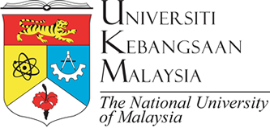

LETTER OF INTENT FOR COOPERATION
BETWEEN
UNIVERSITI KEBANGSAAN MALAYSIA
AND
RETURN LEGACY SDN. BHD. (1080589-X)

In order to promote mutual interests and cooperation between the parties, Universiti Kebangsaan Malaysia through its Faculty/Institute, and Return Legacy Sdn. Bhd., agree to exercise their best efforts to develop academic and research collaboration.

The objective of this cooperation is to investigate the ………………………………………………………...

Both parties shall appoint a coordinator from each party for the development and management of joint activities.
- Prof. Dr. ………………… (Universiti Kebangsaan Malaysia)
- ……………………………….(Return Legacy Sdn. Bhd.)

Both parties understand that all financial arrangements will have to be negotiated and will depend on the availability of funds.

Details for the implementation of specific projects will be mutually developed.

In the event where both parties wish to formalise the above mentioned academic and research collaboration, the parties may enter into an Agreement of which the Agreement shall have a binding effect on both parties.

The undersigned being duly authorised thereto, have signed this Letter of Intent,
on this ………………...

For  UNIVERSITI KEBANGSAAN MALAYSIA | For  RETURN LEGACY SDN. BHD. (1080589-X)
PROF. DR. ……………………………..  Director  Institute of ………………………………………….  Universiti Kebangsaan Malaysia | NAME  Chief Executive Officer  Return Legacy Sdn. Bhd.

