Undergraduate Research Journal for Biological Sciences and Biotechnology

ISSN XXXX-XXXX

The Title of the manuscript should be concise, descriptive and preferably not exceeding 20 words (14pt)

AuthorA¹, AuthorB¹, AuthorC² & AuthorD¹* (12pt)
1Department of Biological Sciences and Biotechnology, Faculty of Science and Technology, Universiti Kebangsaan Malaysia, 43600 Bangi, Selangor, Malaysia (10pt)
2Department of xxx, Institute of xxx, State, Country
* e-mail of corresponding author: xxx@ukm.edu.my

Abstract: The manuscript must include an abstract, describing its main points not more than 200 words in the Malay and English language. If the article was written in Bahasa Malaysia, then the Bahasa Malaysia abstract must precede the English abstract. If the article was written in English, the English abstract must precede the Malay abstract. Assistance will be provided by the editorial board for non-Malaysian to write the Bahasa Malaysia abstract. The abstract should be clear and informative when read in isolation. It should contain a problem statement, research objectives, methodology, results and conclusion. Both abstracts must be written single spacing and both the font size of 10. The manuscript should be supplied with 3-5 keywords after the abstract and separated by semicolon. (10pt)

Keywords: Abstract; language; manuscript; number of words (10pt)

Abstrak: Setiap manuskrip mesti menyertakan abstrak yang menerangkan isi utama manuskrip dalam tidak lebih daripada 200 patah perkataan, ditulis dalam kedua-dua bahasa iaitu Bahasa Malaysia dan Bahasa Inggeris. Jika artikel ditulis dalam Bahasa Malaysia, abstrak dalam Bahasa Malaysia mesti didahulukan diikuti oleh abstrak dalam Bahasa Inggeris. Jika artikel ditulis dalam Bahasa Inggeris, abstrak dalam Bahasa Inggeris mesti didahulukan diikuti oleh abstrak dalam Bahasa Malaysia. Bagi penulis bukan warganegara Malaysia, bantuan akan diberikan oleh pihak editorial untuk menulis abstrak dalam Bahasa Malaysia. Abstrak perlu ditulis dengan jelas dan memberikan maklumat yang mencukupi walaupun dibaca secara berasingan. Kandungan abstrak mesti merangkumi penyataan masalah, objektif kajian, metodologi, hasil kajian, dan kesimpulan. Kedua-dua abstrak hendaklah ditulis dengan jarak tunggal dan menggunakan saiz fon 10. Selepas abstrak, manuskrip perlu disertakan dengan 3 hingga 5 kata kunci yang dipisahkan dengan tanda koma bertitik (semicolon).

Kata kunci: Abstrak; bahasa; manuskrip; patah perkataan

Introduction (11pt)

The Journal publishes manuscripts written in the Bahasa Malaysia and English language. The length of the manuscript must not exceed 8 pages when the template was used. The manuscript should not have more than a combination of 8 figures and tables. The Title of a manuscript should be concise, descriptive and preferably not exceeding 20 words. Title must be provided in both Bahasa Malaysia and English languages. (11pt)
The main title, (Bahasa Malaysia or English depending on the language of the article) must be written in “Title Case”, Times New Roman, bold, centered and font size 14. The translated title (English or Bahasa Malaysia depends on the language of the article) must be provided beneath the main title, using “Title Case” in bracket, centered and font size 12. The manuscript should be divided into the following sections: 1. Introduction, 2. Materials and Methods, 3. Results and Discussion, Conclusion, Acknowledgements (if any) and References. If required, the Results and the Discussion section can be separated.
The text of the manuscripts should be single spacing and 11-points Times New Roman. Headings of sections should be in Title Case, numbered, bold and flushed to the left (Example: 1. Introduction; 2. Materials and Methods). Subheadings should be typed in sentence-case, numbered, italics and flushed to the left. The text should be typed one space below the section heading/subheadings. The first paragraph after the headings or subheadings should be flush to the left. The second paragraph needs a tab.

Materials and Methods

  - Study area

The Materials and Methods section should focus on detailing the procedures and data analysis used in the study. For field studies, it is recommended to include a comprehensive description of the study site to provide context and enhance the reproducibility of the research (Figure 1).

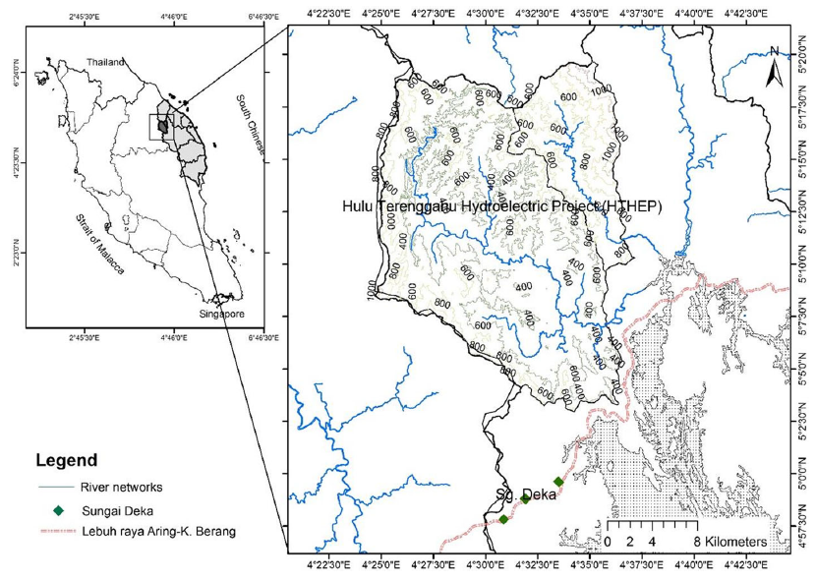

Figure 1. The location of study site: Hulu Terengganu Hydroelectric Project (HTHEP), Terengganu, Peninsular Malaysia. The inset map shows the pre-inundation phase of Puah Catchment area with tributaries is still visible. Adapted from Nasruddin-Roshidi et al. (2021).

  - Experimental design

    - Sub-experiment design-1 (replace with your sub-sub-title of experimental design)

Xxxxxxx.

    - Sub-experiment design-2 (replace with your sub-sub-title of experimental design)

Xxxxxxx.

  - Data analysis

Xxxxxxx.

Results and Discussion

The manuscript should be divided into the following sections: 1. Introduction, 2. Materials and Methods, 3. Results and Discussion, Conclusion, Acknowledgements (if any) and References. If required, the Results and the Discussion section can be separated.

  - Results-and-Discussion-1 (replace with your sub-sub-title of results-and-discussion)

Authors should take note of the limitations set by the size and layout of the journal. Large tables should be avoided. All tables should be included in the manuscript at the site where the authors want it to be. Each table should be provided with a brief and self-explanatory title. The title of the table must be on the top of the table. The font size for the title is 10, single-spaced, sentence case, bold and centered. The font size for the information in the table is 10.
If necessary, footnotes could be provided underneath the table with font size of 10. Vertical lines should not be used to separate columns. Wherever possible, large data set should be presented in two or more tables for clarity. Table should be numbered as Table 1, Table 2, Table 3…

Table 1. Species richness changes: shared species, local extinction, immigration and turnover rate, throughout the dam development phases.
Phase | PL-IN | PL-OP | CN-IN | CN-OP | IN-OP
Shared species | 80 | 107 | 40 | 39 | 59
Extinction | 194 | 169 | 67 | 28 | 33
Immigration (recolonisation/newly recorded) | 10 | 24 | 25 | 92 | 23
Turnover rate | 61% | 51% | 61% | 63% | 26%

  - Results-and-Discussion-2 (replace with your sub-sub-title of results-and-discussion)

Figures and photographs are to be labelled as Figures. All tables should be included in the manuscript at the site where the authors want it to be. The title of the illustrations must be below the illustration. The font size for the title is 10, single- spaced, sentence case, bold and centered. Figure legend must be underneath the title with font size 10, single-spaced, sentence case, and centered.
Illustrations should be numbered according to their sequence in the text. References should be made in the text preceded the illustration. Line drawings and letterings should be bold enough to allow a reduction of 50% (if necessary) without becoming illegible. The font in the illustrations should be standardised. Figures should be numbered as Figure 1, Figure 2, Figure 3…

Conclusion

The Conclusion must be presented in a single paragraph, summarising the key findings of the study and their implications. It should emphasise the significance of the results in addressing the research objectives and provide a concise statement on their contribution to the field. Avoid introducing new information or citations in this section.

Acknowledgements

The Acknowledgments section should be concise while fully recognizing all sources of institutional, private, and corporate financial support for the study. Additionally, any potential conflicts of interest must be clearly disclosed.

References (11pt)

Addis, D., Das, S., Junge, K. and Beller, M. 2011. Selective reduction of carboxylic acid derivatives by catalytic hydrosilylation. Angewandte Chemie International Edition 50(27):6004–6011. (10pt)
Akhtar, M. K., Turner, N. J. & Jones, P. R. 2013. Carboxylic acid reductase is a versatile enzyme for the conversion of fatty acids into fuels and chemical commodities. Proceedings of the National Academy of Sciences USA 110(1): 87-92.
Bezier, D., Park, S. and Brookhart, M. 2013. Selective reduction of carboxylic acids to aldehydes catalyzed by B(C6F5)3. Organic Letters 15(3):496–499.
European Commision. 2014. International Bioeconomy Profile. Brussels: European Commission. Falconnier, B., Lapierre, C., Lesage-Meessen, L., Yonnet, G., Brunerie, P., Colonna-Ceccaldi, B., Corrieu,
G. and Asther, M. 1994. Vanillin as a product of ferulic acid biotransformation by the white-rot fungus Pycnoporus cinnabarinus I-937: Identification of metabolic pathways. Journal of Biotechnology 37(2): 123–132.
Li, C., Matsuda, Y., Gao, H., Hu, D., Yao X. S. and Abe, I. 2016. Biosynthesis of LL-Z1272b: Discovery of a New Member of NRPS-like Enzymes for Aryl-Aldehyde Formation. Chembiochem Communicatons 17(10):904–907
OECD. 2001. The Application of Biotechnology to Industrial Sustainability – a Primer. Paris: Organization for Economic Co-operation and Development.
Schwendenwein, D., Fiume, G., Weber, H., Rudroff, F. and Winkler, M. 2016. Selective enzymatic transformation to aldehydes in vivo by fungal carboxylate reductase from Neurospora crassa. Advanced Synthesis and Catalysis 358(21): 3414 - 3421.
Stolterfoht, H., Steinkellner, G., Schwendenwein, D., Pavkov-Keller, T., Gruber, K. & Winkler, M. 2018. Identification of Key Residues for Enzymatic Carboxylate Reduction. Frontiers in Microbiology 9(250).
Studier, F. W. 2005. Protein production by auto-induction in high-density shaking cultures. Protein Expression and Purification 41(1): 207-234.
Qu, G., Guo, J., Yang, D. and Sun, Z. 2018. Biocatalysis of carboxylic acid reductases: phylogenesis, catalytic mechanism and potential applications. Green Chemistry (Advance Article/In Press).
Wang, M., Beissner, M. and Zhao, H. 2014. Aryl-aldehyde formation in fungal polyketides: discovery and characterization of a distinct biosynthetic mechanism. Chemistry and Biology 21(2):257–263.
Winkler, M. 2018. Carboxylic acid reductase enzymes (CARs). Current Opinion in Chemical Biology
43:23–29.
Winkler, M. and Winkler, C. K. 2014. Trametes versicolor carboxylate reductase uncovered. Monatshefte für Chemie 147:575–578.

