Study of Commonly Found Herbs in Malaysia and Its Ability of Anti-Mosquito Effect Shasvindaran A/L Rameash, Surindran A/L Govalen,
Sanjay Aravin A/L Murugan, Navaneetha Krishna A/L Chandran, Homathevi Rahman,
Ahmad Firdaus Hadi, Vijaya Kumar Rahman
SMK Ulu Tiram, Jalan Sungai Tiram,
81800 Ulu Tiram, Johor, Malaysia

Abstract
Mosquitoes are the most important insect vectors of human disease posing a great threat to our health to which most of the time leads to death. To date mosquitoes have been identified as a vector for diseases such as dengue, dengue hemorrhagic fever, equine encephalitis, yellow fever, malaria and zika. As the spread of the diseases increase, several efforts have been put to control or eradicate mosquitoes. There are many ways to get rid or control this insect but mostly using chemicals and often have side effects on the other living things and environment. The aim of this research is to test and identify locally available herbs which can be instantly used to keep away mosquitoes from human and thus get rid the unwanted disease. Leave extracts from four types of herbs, pudina (Mentha × piperita), neem (Azadirachta indica), indian borage (Plectranthus amboinicus) and basil (Ocimum basilicum) were tested against adult mosquitoes and its larvae. The result showed that extract of Indian borage effectively repels the adult mosquito and also kills the larvae. Indian borage is a common herb used for cough in Indian traditional medicine practice. The results showed that extracts of Indian borage is able to effectively prevent mosquito from biting and also kill the mosquito larvae within a significant time.
Keywords: mosquitoes, diseases, local herbs, extracts

Study of Commonly Found Herbs in Malaysia and Its Ability of Anti-Mosquito Effect
Death caused by mosquito related disease has been increasing lately and cases reported recently touched an alarming rate. In 2015 about 12, 0836 dengue cases were reported with 336 deaths (Online, thestar, Wednesday, 6 January 2016). These are not the only threat, but there are much more such as malaria, zika, chikungunya and others. To control the population of mosquito is almost impossible because they just require as little as an inch of standing water to lay egg and reproduce. While we can control mosquito in our surrounding, controlling mosquito from other areas especially bushes are almost impossible because their ability to fly. For example, the flight range of malaria causing mosquitos or An. maculatus has been estimated to be about 1.25 km (Sandosham and Thomas, 1982).
Best option we have to reduce mosquito related cases is to stop them from biting us. In short we needed something that gives the repelling kind of effect without using chemicals or dangerous substances. “Extensive use of synthetic insecticides during the last five decades has resulted in environmental hazards and also in the development of physiological resistance in major vector species. This has therefore necessitated the need for research and development of environmentally safe, biodegradable, low cost, indigenous method for vector control, which can be used with minimum care by individual and communities in specific situation” (Mittal et al., 2003).
In order to find effective natural mosquito repellent, several researches have been conducted. Many herbs have been tested to repel mosquito and kill the larvae. However, most of the herbs usage ended up being burnt to produce smoke (which can cause fire danger and air pollution) to get the effect of repelling. In some cases, it has to be a mixture with other substances such as chemicals, essential oil or plants which may require quite a complex process to produce repellent which can deter the mosquito from biting. Lawal et al. (2012) has carried out research on six plants to formulate potent herbal mosquito repellent. They investigated the repellent effectiveness biologically to develop environmental friendly and effective herbal mosquito repellent for the control and prevention on mosquitoes.
To date research on known local herbs and their ability to stop the mosquito from biting human and their effect on mosquito larvae is still not enough. The aim of this paper is to test commonly found herbs in Malaysian’s backyard or garden that can effectively help to reduce number of mosquito related disease by preventing them from biting humans.
Method
This study was conducted at SMKUT (SMK Ulu Tiram, 81800, Ulu Tiram, Johor). Four types of commonly used herbs, Mentha piperita (pudina), Azadirachta indica (neem), Plectranthus amboinicus (indian borage) and Ocimum basilicum (basil) were selected for the purpose of this study. Leave extracts from the selected herbs were tested against adult mosquitoes and its larvae.
Fifty grams of leaves for each herb were cleaned and pounded gently in a bowl. The leaves were pounded until pure solution of the leaves obtained (Figure 1). The concentration of solution for each of the herbs was maintained with mass per volume and further tested as repellent against adult mosquitoes (Test 1) and as killing agent for the larvae (Test 2).
In Test 1, a double sided container with holes was used. Ten adult mosquitoes were randomly caught and released in the container. The holes were stuffed with fingers (Figure 2). Each finger was placed inside the holes with (test extract) and without (control) the extract for 15 minutes. Number of mosquitoes seated on the finger were observed and recorded. The procedures were repeated for all plant extracts.
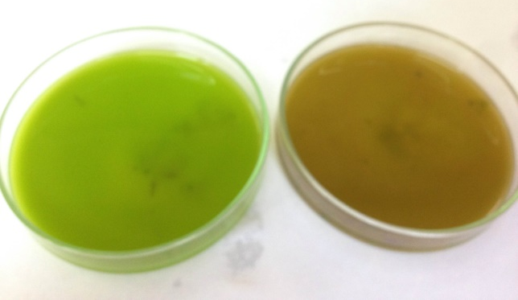
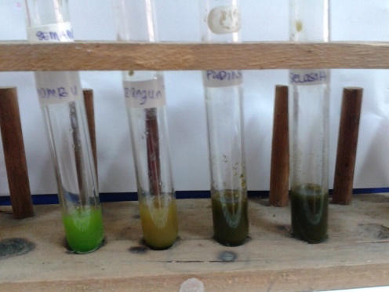

Figure 1. Pure solution of the leaves

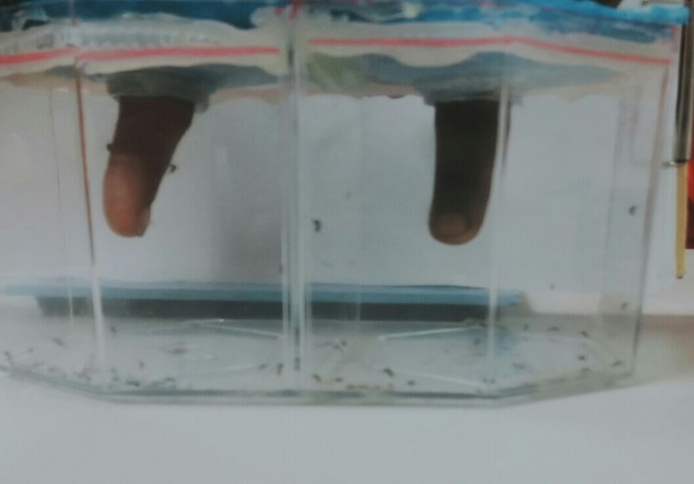

Figure 2. Testing the extract against adult mosquitoes

In Test 2, the extracts of each plant were tested against mosquito larvae. The concentration of the extracts was maintained with mass per volume and 20 ml of each extracts were used in this test. The extracts were poured in a petry dish and five mosquito larvae of similar sizes were released into the dish. A control petri dish with sterilized water was used. For every 35 minutes, another five live larvae were added to each petry dishes. All the procedures were repeated five times and state of larvae activity were observed and recorded.
Results
The results showed that in most cases the mosquito’s sensitivity towards the extracts were different. Results of Test 1 showed that extracts of Plectranthus amboinicus was not favoured by adult mosquitoes (Table 1). At least five to four mosquitoes were observed seated on fingers applied with extracts of other plants and also without any extracts. None of the mosquitoes were seated on fingers applied with extracts of Plectranthus amboinicus. This shows that the mosquitoes do not like to sit or bite finger applied with Plectranthus amboinicus extract.

Table 1
Number of adult mosquitoes seated on fingers with and without plant extracts
Finger with plant extract | Number of Mosquito try to bite
Pudina | 4
Neem | 5
Basil | 4
Plectranthus amboinicus | 0
Without any extract | 5

Similar results were obtained in Test 2 of which the extracts of Plectranthus amboinicus, seen effectively killing the mosquito larvae. All the tested larvae died after 35 minutes released into the extracts. Meanwhile none of the larvae died in other extracts including the controls.

Table 2
Plant extracts effect on mosquito larvae
Type of plant | Time taken for mosquito larvae to die (min)
MINT | 0
Neem | 0
BASIL | 0
Plectranthus amboinicus | 35

Conclusion
From the results we can conclude that the Indian borage or Plectranthus amboinicus have good repellent quality and able to kill the mosquito when it is in larvae stage. This plant is easy to grow, cheap and easily available anywhere makes it a potential bio repellent for mosquito. However, while we are able to identify these herbs which has anti-mosquito (adult and larvae) effect, a further and depth study is needed to verify further the effect of this plant on various species of mosquitoes. Further studies are also crucial to identify component or substance in the plants that actually killed the larvae. This research will be carried further under the collaboration and supervision by Associate Professor Dr Homathevi Rahman, Universiti Malaysia Sabah and Dr Dayang Norulfairuz Abang Zaidel, Universiti Teknologi Malaysia.

References
Sandosham AA, Thomas V. (1982). Malariology with special reference to Malaya. Singapore University Press. 382 pp
Mittal PK & Subbarao SK. (2003). Prospects of using herbal products in the control of mosquito vectors. ICMR Bull. 33, 1– 10
Lawal, H.O., Adequyi, G.O., Fawehinmi, A.B., Adeogun, A.O. and Etatuvie, S.O. (2012). Bioassay of herbal mosquito repellant formulated from the essential oil of plants. J Journal of Natural Products 5:109-115
Online, The Star. (2016, January 06). 50% rise in dengue deaths. Retrieved October 19, 2016, from http://www.thestar.com.my/news/nation/2016/01/06/50-rise-in-dengue-deaths-health-ministry-upward-trend-also-observed-in-other-countries/

