Copyright © 2016 American Scientific Publishers *Advanced Science Letters*

All rights reserved Vol. xx, yyy–zzz, 2016

Printed in the United States of America

**Development of Conjugate Aurora**

**Observation in Iceland**

Wayan Suparta1, Akira Kadokura2, Gunnlaugur Bjornsson3

1*Space Science Centre (ANGKASA), Institute of Climate Change, Universiti Kebangsaan Malaysia,*

*43600 Bangi, Selangor Darul Ehsan, Malaysia*

2National Institute of Polar Research, 10-3, Midoricho, Tachikawa, Tokyo 190-8518, Japan

*3Science Institute, University of Iceland, Dunhagi 3, IS-107 Reykjavik, Iceland*

A conjugate aurora observation between Iceland and Antarctica has been developed in Husafell started from September 2008 to August 2018 with a new additional plan at Manarbakki, Tjornes station. This observation was conducted using ground-based GPS receivers through the effects on interhemispheric conjugate points. The ionospheric total electron content (TEC) from GPS during a weak substorm interval recorded at the northern and southern geomagnetic conjugate points at Husafell in Iceland and Syowa in Antarctica was investigated. The conjugate point auroral features were observed using simultaneous all-sky camera (ASC) measurements. We selected ASC images at Tjörnes and Syowa during the interval 00:18:12 - 00:50:24 UT on 21 September to study their response on the GPS signals. Based on a detailed comparison of ASC images with TEC variation, we identified that their connections are clearly well-developed only between the regions where the geomagnetic field lines are closed in the footprints of the geomagnetic conjugate points. This implies that the GPS receiver capable used to monitor indirectly the aurora event which coincidently enhanced the TEC due to particle precipitation in the structure of the F-region.

**Keywords:** GPS TEC, Auroral activity, Conjugate points, Development.

**1. INTRODUCTION**

The effects of space weather can range from damage to satellites arising from charged particles to disruption of power grids on Earth during geomagnetic storms, radio black-out on transpolar aircraft routes, or disturbance of satellite positioning systems1. Aurora is one of the space weather phenomena, which are in turn caused by charged particles interacting with the magnetosphere2. Auroras which commonly visible at night between 65 to 72 degrees north and south latitudes are more frequent and brighter during the intense phase of the solar cycle when coronal mass ejections increase the intensity of the solar wind, and particles are accelerated along the Earth’s geomagnetic field.

*Email Address: wayan@ukm.edu.my

Since the space weather strongly affected the satellite communication systems, such as Global Positioning System (GPS) signals, it would be benefited to study their refracted, reflected and scattered signals to be used to remotely sense the Earth’s surface and beyond, such as the ionosphere. In this study, we aim to develop conjugate aurora observation and to observe the auroral features at the geomagnetic conjugate points between Husafell in Iceland and Syowa in Antarctica. The ionospheric total electron content (TEC) derived from GPS is proposed to monitor the dynamics of upper atmosphere during the aurora event. The argument is that the upper atmosphere measured by TEC is strongly affected by solar activity during geophysical disturbances as indicated by the strength of geomagnetic field and particularly through interhemispheric conjugate points.

**2. METHODOLOGY**

The TEC changes during a weak substorm interval will be demonstrated through conjugate points between Syowa (SYOG: 69.00°S, 39.58°E) and Husafell (HUSA: 64.67°N, 338.97°E). The location of the study and the system setup is depicted in Figure1. We used auroral data measured at Tjörnes (TJOR: 66.21°N, 342.89°E) in Iceland. TJOR is one of the bigger stations maintained by the National Institute of Polar Research (NIPR) Japan, which is about 400 km northeast of HUSA. TJOR and the conjugate point of HUSA are calculated by the International Geomagnetic Reference Field (IGRF) models.



**Fig. 1**. The blue star in the left side is the current GPS station in Iceland (installed in September 2008) and the red box is planned for Manarbakki, Tjornes station and the right side show the location of the observatory.

To support the response of TEC on aurora activity, and to determine the precise auroral morphology of an interhemispheric conjugate point, we used the simultaneous all-sky camera (ASC) measurements data recorded at TJOR-SYOG. The investigations will be focused on 21 September 2009, which covers the period from 20 to 22 September. The measurements of the interplanetary magnetic field (IMF) from Advanced Composition Explorer (ACE) are employed to identify the geophysical disturbances as presented in Figure 2(a). The ACE satellite is positioned at a Lagrangian L1 point (a point of Earth-Sun gravitational equilibrium at ~240 RE) from the Earth toward the Sun (or ~35 RE from Sun-Earth line)3. From its location, it has a key view of the solar wind, IMF and higher energy particles accelerated by the Sun. The record of fluxgate magnetometer for *H* component at HUSA in Iceland and SYOG in Antarctica were also observed in Figure 2(b). The time resolution of the ground magnetometer data was given at one-minute intervals. The negative peak onset (00:24 UT) in the geomagnetic *H* component at all stations are coincided with the appearance of the dynamical auroral activity over TJOR. On the orher hand, auroral activity was seen on 21 September 2009 as reported by Motoba et al.4, where after 01:00 UT, the *H* component at all stations shown a rapid decrease and peaked -506.4 nT at 01:02 UT for SYOG, HUSA was -271.20 nT at 01:13 UT and at TJOR was also clearly visible, two minutes later with value -455.40 nT.

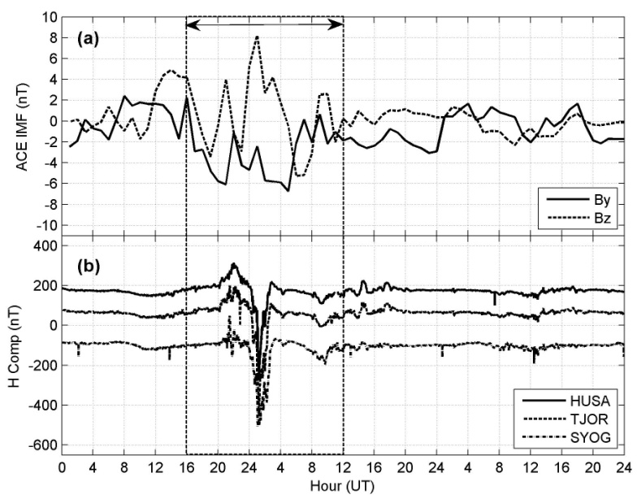

**Fig. 2**. IMF for *By* and *Bz* components (a) ACE spacecraft in GSM coordinates and (b) geomagnetic activity (*H* component) at TJOR, HUSA and SYOG stations for the period from 20 to 22 September 2009. The interval between the dashed lines is an indication of perturbation.

**3. RESULTS AND DISCUSSION**

**3.1. Ionospheric TEC Conditions**

Figure 3 shows the TEC variation in a 15-minute resolution between the conjugate stations between the northern and southern hemispheres for three days. The selection of a 15-minute average is a statistically way to remove the noise and to clarify that the TEC enhancement in this case is due to the auroral activity. The vertical TEC is calculated based on the method presented in Hofmann-Wellenhof et al.5. Due the ionospheric pierce points of the TEC for different satellites are different; we used the Differential Code Bias (DCB) obtained from the AIUB Data Center of Bern University, Switzerland to correct the inherent instrumental biases. The biases have been estimated as constant values for each day.



**Fig. 3**. Vertical TEC variations at 15 minutes average over the period from 20 to 22 September 2009 at SYOG and HUSA stations. The dash circle between the perturbation areas shows the TEC anomaly for HUSA and the TEC enhancement at SYOG is shown by the arrow position.

The TEC variation at HUSA in Iceland and in Antarctica (SYOG) in Figure 3 showed a similar pattern. However, the TEC peak at HUSA was seen late a few hours than at SYOG, which expected due to the daily variations between Syowa and Iceland. The different times between Iceland and Syowa, Antarctica in GMT reference is about 3 hours, where Iceland is behind the Syowa. For the interval from 12:00 UT on 21 September onward, the TEC fluctuation and the peak was similar to the TEC on 20 September. This similar TEC pattern during low sun activity can clearly be seen to be different from the TEC pattern during the period of perturbation. On a different note, the daily TEC variation was shown to closely follow the diurnal pattern. Referring to the perturbation period (from 16:00 UT on 20 September to 12:00 UT on 21 September), TEC at HUSA was peaked at around 01:10 UT on 21 September as indicated by an up arrow. Details of the TEC response during the perturbation period are presented in the following section.

**3.2. Interconnection between TEC and Auroral Activity**

Figure 4 shows the selected image pairs from the ASC images at TJOR and SYOG after the negative peak onset at 00:47:24 – 00:50:24 UT on 21 September. The two spiral-like auroras observed at TJOR are marked as α and β, and the counterparts at SYOG of α and β at TJOR are marked by α’ and β’, respectively. Four of east-west aligned spiral-like auroral arcs were identified moved eastward in both ASC field of views (FOVs) and each of them had a similar form between TJOR and SYOG. However, only the third and the fourth spiral-like auroral arcs were expected to have the conjugate point of SYOG mapped onto the TJOR. The spiral-like auroras at TJOR at 00:47:24 UT (Figure 4a) were shown moving eastward without a major structural change. At SYOG, a part of the trailing spiral-like aurora (β') began to appear at the westward edge of the ASC FOV at 00:48:44 UT (Figure 4b). Similar to the leading spiral-like aurora at TJOR, the counterpart at SYOG is also moved eastward and then reached the SYOG zenith at 00:49:24 UT (Figure 4c, bottom). At 00:50:04 UT (Figure 4d), the leading spiral-like aurora passed out of the ASC FOV at TJOR, whereas the trailing one (β) approached the zenith. At 00:50:24 UT (Figure 4e, top), a similar spiral like aurora was seen at TJOR, and a part of the trailing spiral-like aurora (β') at SYOG appeared near the westward of the ASC FOV.

By comparing Figures 4 and 3, the conjugate auroras in the late stage of the substorm (after 00:45 UT) at both TJOR and SYOG shows similar features. We expect at this time the auroral activity to have communicated with the ionospheric TEC via solar wind. The explanation is that a weak substorm was started at around 00:15 UT on 21 September and intensified at around 00:55 UT. Then, it reached the peak at around 01:15 UT and the development of this substorm appeared ended at around 02:40 UT on 21 September. The interval of 00:47 - 00:50 UT (Figure 3) shows the TEC variation at HUSA and SYOG, which was increased and peaked 20 minutes later to about 9.0 and 7.3 TECU, respectively. This time difference is caused by the auroral poleward expansion developed from the lower latitudes to higher latitudes. At the same time (around 01:10 UT on 21 September), a slight increase in the TEC values have been found correlated with ASC profiles at TJOR. On the other hand, we highlighted that the TEC enhancement during a weak substorm can be understood by the enhancement of electron density in the E- and F-regions created by the precipitating auroral electrons associated with the auroral activity.

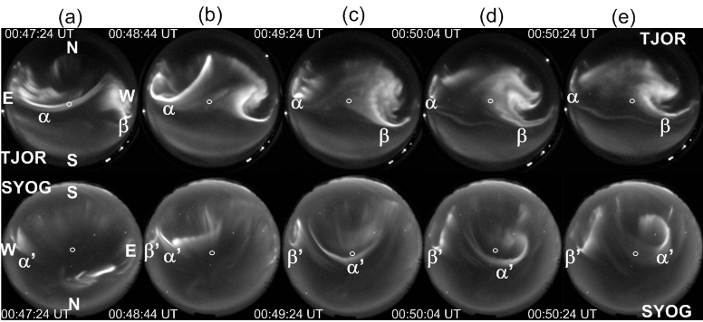

**Fig.4**. Auroral activity during the interval 00:47:24 – 00:50:24 on 21 September 2009. The first and the second spiral-like aurora arcs are labeled α and β at TJOR (α' and β' at SYOG), respectively6.

**3.3. TEC Response at Conjugate Points**

To distinguish more clearly that TEC enhancements are due to auroral precipitation, visualization of GPS satellites through pseudo random noise (PRN) route is demonstrated in the form of satellite visibility diagrams (skyplot)7. Figure 5 shows the skyplot of GPS data for HUSA and SYOG stations with a 30s interval during the period of 00:00 UT to 02:00 UT on 21 September. In this skyplot, which PRN may respond to the aurora is by looking their tracks towards the center of the station. From perspective of the receiver, it shows at SYOG that PRN#11 and PRN#28 are moving towards the center point of the site, while PRN#19 and PRN#3 are leaving the position. For HUSA, satellite closest to the center point is PRN#2 and PRN#13, while PRN#4 and PRN#23 seen leaving the center point. From this visibility, we plotted the TEC values from selected PRN for both stations. The blank values in the figure indicated the satellite is invisible.

From the figure shows that the TEC response to the aurora at SYOG appears to be simply the diurnal variation compared to the TEC variation at HUSA. This can be seen that only PRN#19 appear toward the SYOG site than the two PRNs (#4 and #13) at HUSA for the period between 00:30 UT and 01:30 UT. Outside the second circle from the center of the site shows that the TEC variation is small due to incomplete tracking.

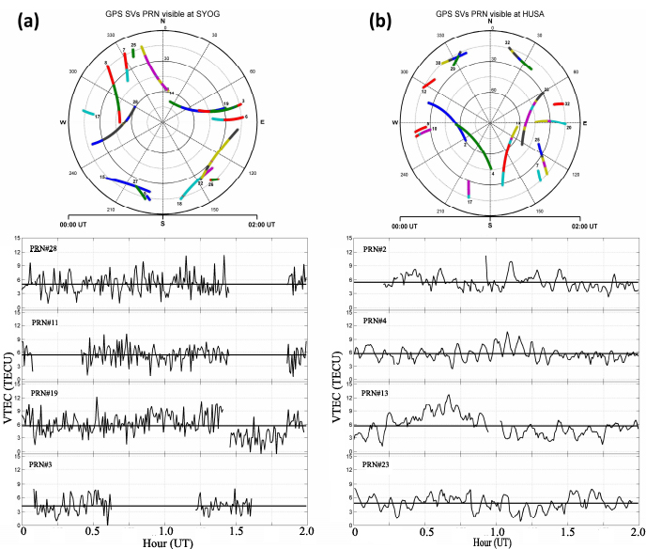

**Fig. 5**. **Above**: skyplot for PRN# visible during the GPS Time from 00:00:00 to 02:00:00 UT on 21 September 2009 at (a) SYOG and (b) HUSA. The satellite vehicle number in the figure shows the end of the tracking. **Below**: vertical TEC variation at both stations and their mean VTEC (horizontal solid line) for selected PRN.

When all this VTEC averaged, it will be obtained below 6 TECU. The average of TEC increase from their mean values during the period from 00:30 UT to 01:30 UT of four selected PRNs was 1.23 TECU and 1.65 TECU for SYOG and HUSA, respectively. Increases of these values are consistent with Figure 3, which possibly associated with particle energization and precipitation during a weak substorm events. Although the aurora event occurred below a 2-h and with a weak substorm, the TEC enhancement is suggested due to the particle precipitation in the structure of the F-region. These characteristics show that the TEC enhancement will have a clear response on the station that only to have a conjugate point.

**5. CONCLUSIONS**

This paper has successfully demonstrated the development of aurora observation through GPS signals at the conjugate points between Iceland (Husafell and Tjornes) and Syowa, Antarctica. Based on the detailed comparison of both ASC images with temporal TEC variation during the interval 00:18:12 – 00:50:24 UT on 21 September, we have identified that the northern geomagnetic footprint of SYOG was displaced poleward of TJOR by up to ~3 degrees or more in the initial stage of substorm developments. We have highlighted that the dynamic motion of the auroral activity on the conjugate points has affected the GPS signals as a consequence of varying in the reconfiguration of the tail field and associated particle energization and precipitation.

Although temporal drift of conjugate point of Syowa in Iceland has occurred, the TEC was increased of about 3 TECU on average, observed from 00:00 to 02:00 UT on 21 September 2009. The increase of TEC during a weak substorm can be understood as an increase in the electron density of the upper atmosphere due to charged-particle precipitation in a region of auroral activity. However, to clarify the connection between TEC enhancement and the spiral-like aurora remaining a further investigation because it seems that not all the auroral arc features affect the GPS TEC. The investigation may be expanded during the solar maximum with providing a high quality of long-term GPS data.

**ACKNOWLEDGMENTS:** This work partially supported by the grant DPP-2014-054 of Universiti Kebangsaan Malaysia. The authors would like to thank Snorri Johannesson for maintaining the GPS system and kind hospitality shown during our stay at Husafell, Iceland. Gratitude is also expressed to the ACE team at NASA GSFC for maintaining the solar wind data at CDAWeb and NIPR Japan for providing ground magnetometer and aurora data.

**References and Notes**

1. Þ. Arason**,** Aurora and the Earth's magnetic field, **(2012)** http://en.vedur.is/weather/articles/nr/2549.
2. N. Sato, A. Kadokura, Y. Ebihara, H. Deguchi, and T. Saemundsson, Tracing geomagnetic conjugate points using exceptionally similar synchronous auroras, Geophys. Res. Lett. 32 **(2005)** L17109, doi:10.1029/2005GL023710.
3. D. R. Weimer, D. M. Ober, N. C. Maynard, W. J. Burke, M. R. Collier, D. J. McComas, N. F. Ness, and C. W. Smith, Variable time delays in the propagation of the interplanetary magnetic field. J. Geophys. Res. 116 **(2002)** A00I90, doi:10.1029/2010JA015732.
4. T. Motoba, K. Hosokawa, N. Sato, A. Kadokura, and G. Bjornsson, Varying interplanetary magnetic field *By* effects on interhemispheric conjugate auroral features during a weak substorm, J. Geophys. Res. 115 **(2010)** A09210, doi:10.1029/2010JA015369.
5. B. Hofmann-Wellenhof, H. Lichtenegger, and J. Collins, Global Positioning System: Theory and Practice. 7th revised edition, Springer Verlag (**2001**)
6. W. Suparta, W., M. A. Mohd. Ali, M. S. Jit Singh, B. Yatim, T. Motoba, N. Sato, A. Kadokura, and G. Bjornsson, GPS TEC variation affected by the interhemisphericconjugate auroral activity on 21 September 2009, World Academy of Science, Engineering and Technology 60, 1022 **(2011)**
7. J. Marshall, Creating and viewing skyplots. GPS Solut. 6, 118 **(2002)**

Received: 01 October 2014. Accepted: 31 October 2014

Note that table is written as Table I, Table II, Table III, etc. and only three horizontal lines and no vertical line.