**M**

alaysia **Geoheritage** Conference &

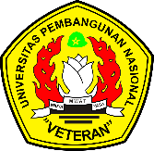

**DEPARTMENT OF NATIONAL HERITAGE**

Ministry of Information Communication and Culture

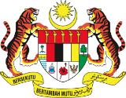

alaysia-Indonesia Geoheritage **Conference** 2015

**REGISTRATION**

Name :.....................................................................................Address :..................................................................................... ...................................................................................... ...................................................................................... ......................................................................................Email :.....................................................................................Tel ;.....................................................................................Fax :..................................................................................... I would like to attend the conference I would like to present the following paper (along with abstract)..............................................................................................................................................................................................................................

I would like to join the mid conference field trip on 3/11/2015

I would like to join the post conference field trip on 5/11/2015

to: Pulau Adang/Tarutao/Satun

(*Place are limited. First come first serve basis. Extra payment for post conference field trip which will be included in the next brochure*)

Digital copy of this registration form can be found at:[http://www.ukm.my/wgm/programs.php](http://www.ukm.my/wgm/programs.php%20)

Please email/fax/post this form before **1st September 2015** to the secretariat or the corresponding person.